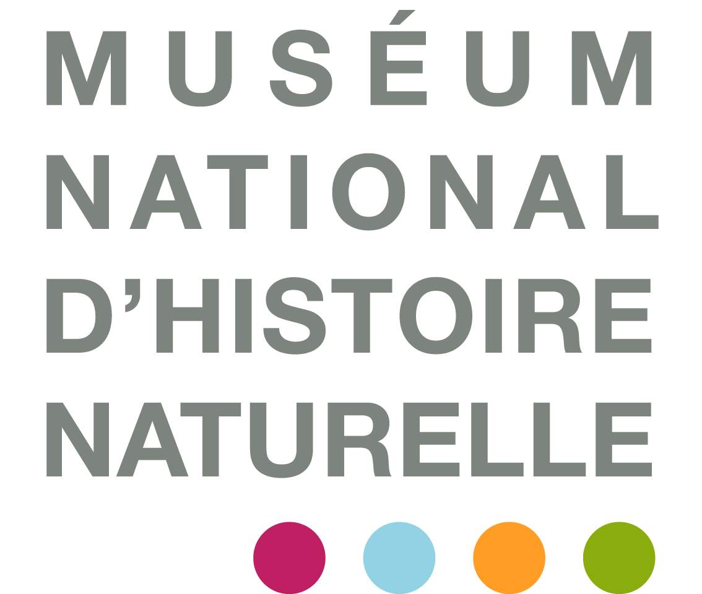





Registration form
6th Meeting of the André Picard Network

29th & 30th of April 2015

Place:
La Citadelle & le Laboratoire de Biologie du Développement de Villefranche-sur-mer, Observatoire Océanographique, Villefranche-sur-mer

Time:
Wednesday 29th of April: 9h00-20h00
Thursday 30th of April: 8h30-16h

Please send this document back to: Sofie Vanmaele
Observatoire Océanologique
Biologie de Développement
UMR7009 CNRS-Univ. Paris VI
181 chemin du Lazaret
06230 Villefranche-sur-Mer cedex France

Or by email: sofie.vanmaele@obs-vlfr.fr

Registration will be open until April 3rd 2015 or as long as places are available.

NAME:

SURNAME:

FUNCTION:

UMR:

GROUP:

WORK ADRESS:

Phone:

Email:

Language: FRANCAIS/ENGLISH

Lunch is offered on both days by SATS-SU, yet registration in advance is obligatory:

Wednesday 29 April: YES / NO
Thursday 30 April: YES / NO

Vegetarian: YES/NO

